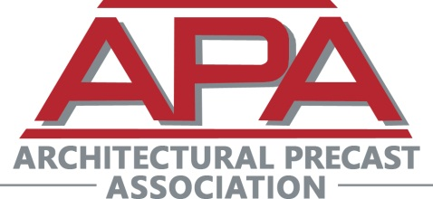
2026 APA Spring Workshop
Charlotte, NC
April 23 – April 26, 2026

SCHEDULE OF EVENTS
(As of 3-17-26)

Thursday, April 23
2:00 p.m. – 5:00 p.m. APA Board of Directors Meeting (Invitation Only)

6:30 p.m. – 8:00 p.m. Reception – Graham Street Pub & Patio (400 S. Graham Street., Charlotte)

Friday, April 24 Plant Tours and On-Site Demonstrations & Training

7:30 a.m. Bus Departs Marriott City Center for Performance Precast (Midland, NC)
8:15 a.m. – 9:15 a.m. Breakfast and Plant Tour of Performance Precast

9:15 a.m. Bus Departs for Lucas Concrete Products (Charlotte, NC)

10:00 a.m. – 12:15 p.m. Plant Tour and Lunch at Lucas Concrete Products

12:15 p.m. Bus Departs for Hendricks Motorsports Heritage Center

1:00 p.m. - 3:00 p.m. Tour of Hendricks Motorsports Heritage Center

1:00 p.m. - 3:00 p.m Plant Tour of Utility Precast (Rotating Groups)

3:00 pm Bus departs for hotel

5:30 p.m. – 6:30 p.m. Evening Cocktails – Stoke Bar (Charlotte, NC)

Saturday, April 25 Classroom Instruction – Charlotte City Center Marriott

8:15 a.m. – 8:40 a.m. Breakfast

8:40 a.m. – 8:45 a.m. Sponsor Presentation

8:45 a.m. – 9:00 a.m. Membership Meeting

9:00 a.m. – 9:05 a.m. Sponsor Presentation

9:05 a.m. – 9:55 a.m. Session #1: “AI Evolution in Solidworks, Entering the Generative Age”, Katy Shemligian & Richard Forcier, SolidXperts

9:55 a.m. – 10:00 a.m. Sponsor Presentation

10:00 a.m. – 10:10 a.m. Break

10:10 a.m. – 10:15 a.m. Sponsor Presentation

10:15 a.m. – 11:00 a.m. Session #2: “Smarter AI for Precast/GFRC, Measure twice, Cast once,” Dustin Williams, Unlimited Designs

11:00 a.m. – 11:05 a.m. Sponsor Presentation

11:05 a.m. – 11:45 a.m. Session #3: “How AI is Changing Architectural Precast,” Blake Allen, IntraSync

11:45 a.m. – 11:50 a.m. Sponsor Presentation

11:50 p.m. – 1:00 p.m. Session #4: “From Drawings to Data: Leveraging AI Across the Precast Workflow,” Rod Johnson, Gavin Johnson, & John Poole

1:00 p.m. – 2:00 p.m. - Closing Lunch

